**Experiment-1**

**Objective :-** Introduction to Pandas, Upload, data preprocessing, NumPy and Matplotlib library in Python.

**Implementation :-**

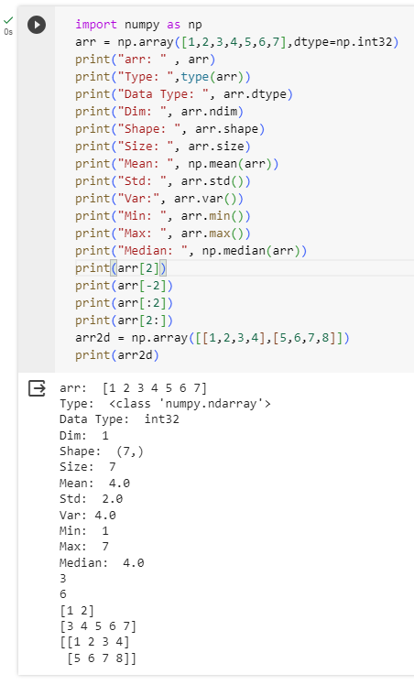

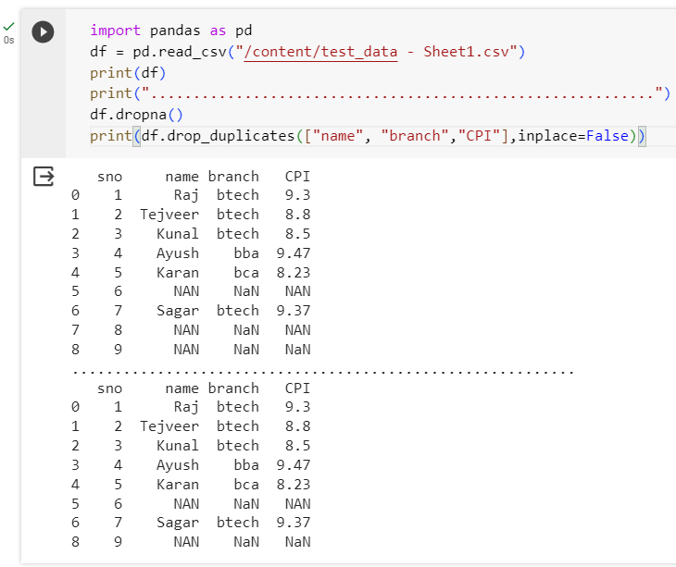

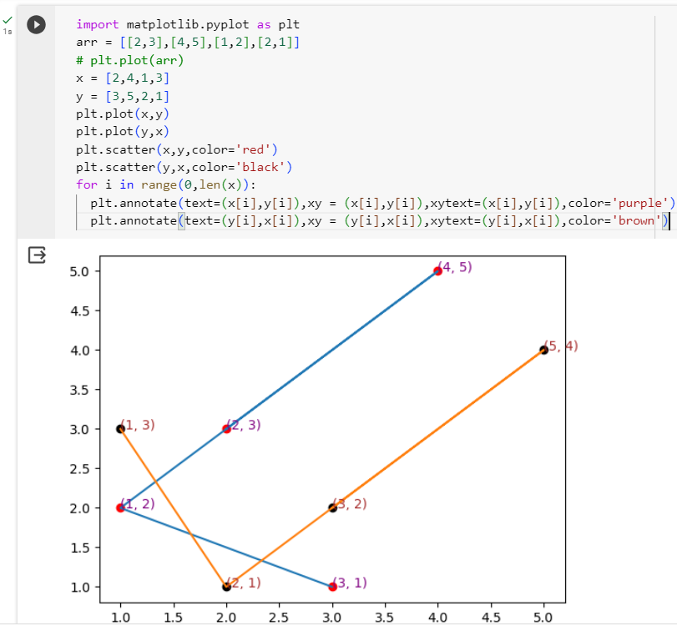

**Experiment-2**

**Objective :-** To Implement Linear Regression with one variable in Python

**Dataset:-**  <https://www.kaggle.com/datasets/krishnaraj30/salary-prediction->data-simple-linear-regression

**Implementation :-**

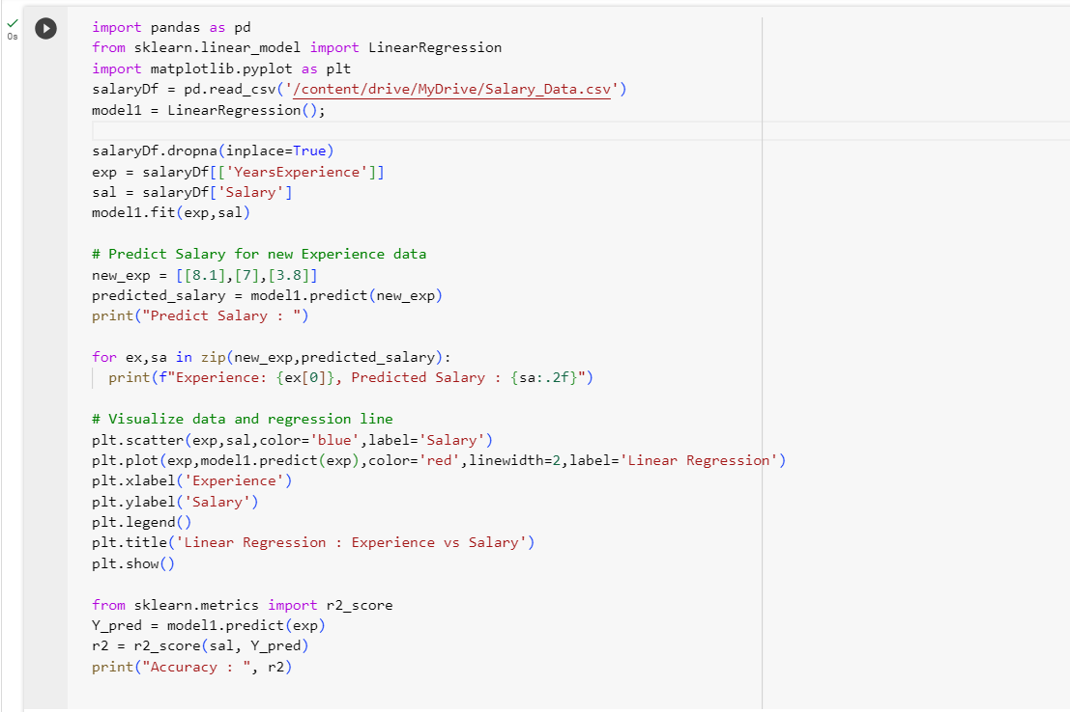

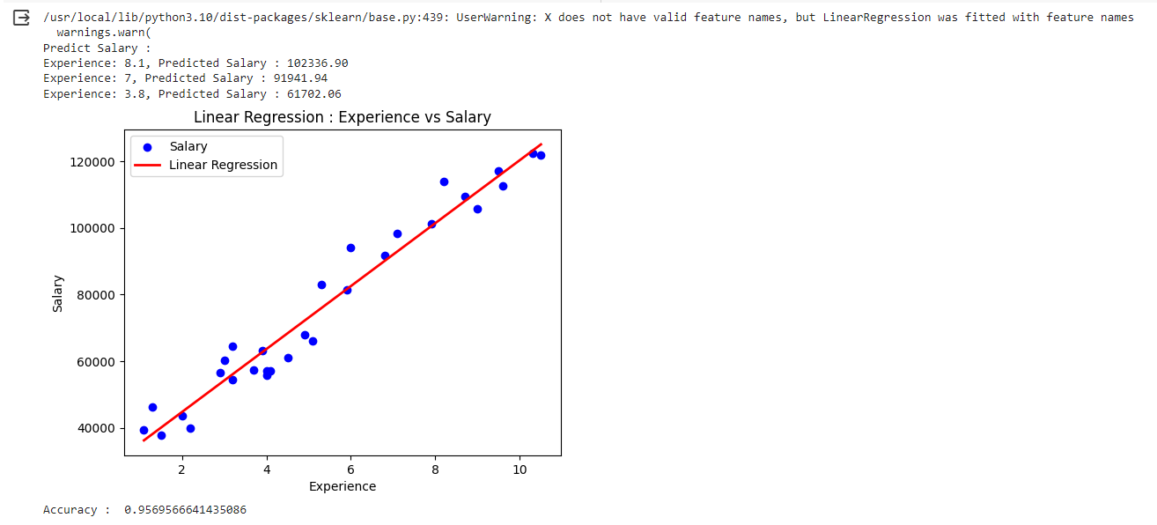

**Experiment-3**

**Objective :-** To Implement Linear Regression with Multiple variable in Python

**Dataset:-**  https://www.kaggle.com/datasets/yasserh/housing-prices-dataset

**Implementation :-**

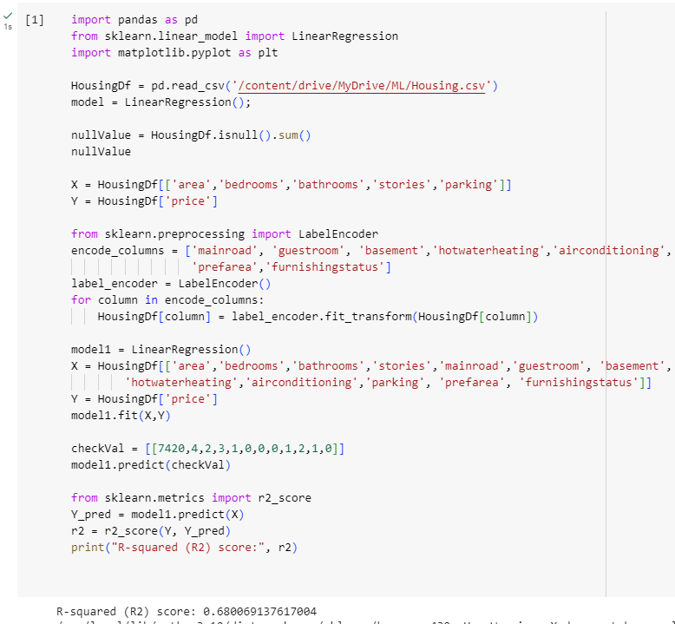

**Experiment-4**

**Objective :-** To Implement Binary Classification using Logistic Regression in Python

**Dataset:-**  <https://www.kaggle.com/datasets/gauravtopre/bank-customer->churn-dataset

**Implementation :-**

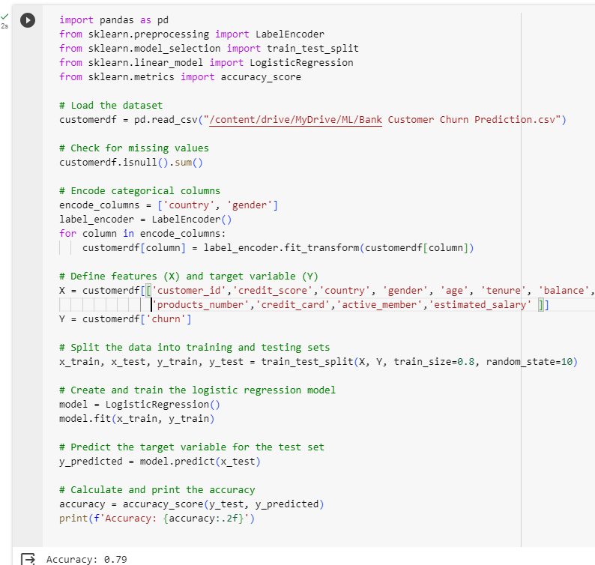

**Experiment-5**

**Objective :-** To Implement Principal Component Analysis in Python

**Dataset:-**  https://data.world/sdhilip/pizza-datasets

**Implementation :-**

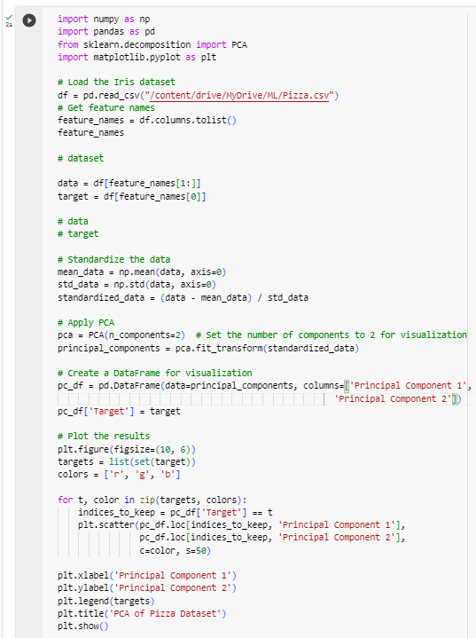

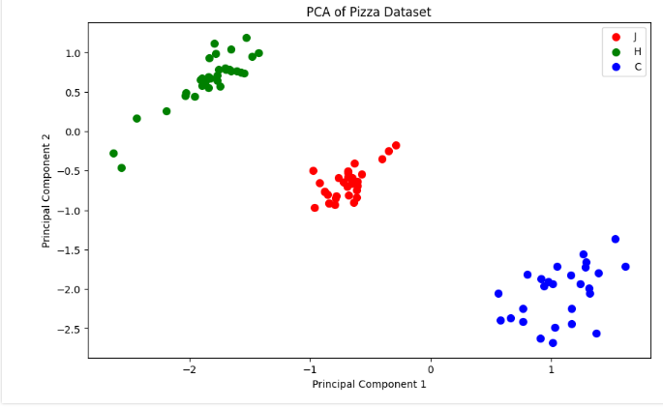

**Experiment-6**

**Objective :-** To Implement Support Vector Machine Classifier in Python

**Dataset:-**  https://archive.ics.uci.edu/ml/machine-learning-databases/iris/iris.data

**Implementation :-**

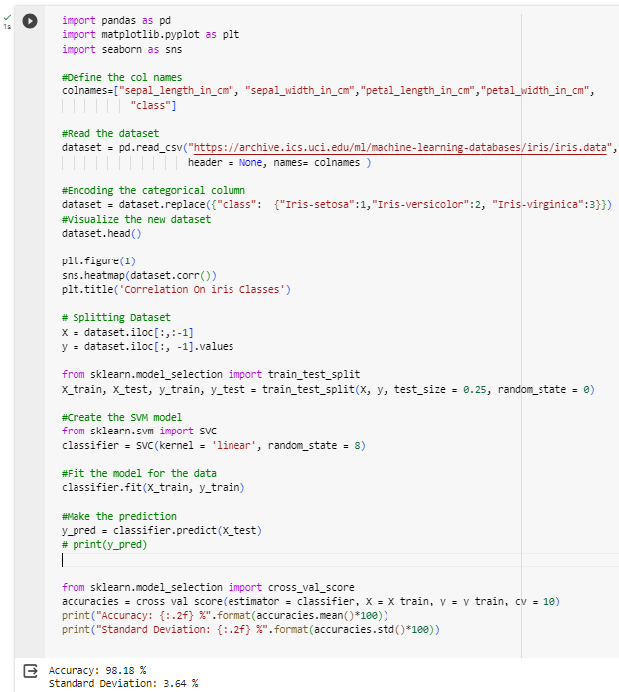

**Experiment-7**

**Objective :-** To Implement Multi-Classification using Artificial Neural Network in Python

**Dataset:-**  https://www.kaggle.com/datasets/hojjatk/mnist-dataset

**Implementation :-**

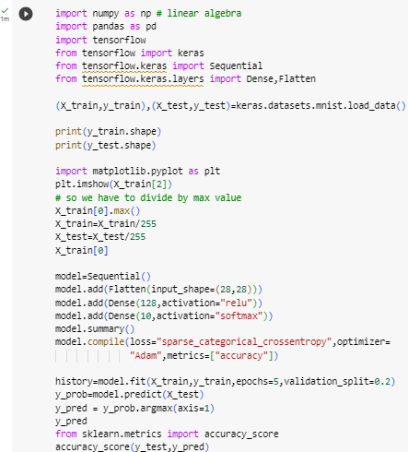

**Experiment-8**

**Objective :-** To Implement Decision Tree (DT) classification in Python

**Dataset:-**  https://cf-courses-data.s3.us.cloud-object-storage.appdomain.cloud/IBMDeveloperSkillsNetwork-ML0101EN-SkillsNetwork/labs/Module%203/data/cell_samples.csv

**Implementation :-**

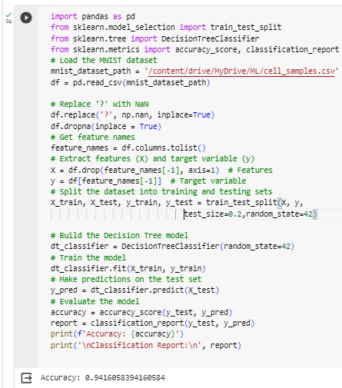

**Experiment-9**

**Objective :-** To Implement K-Nearest Neighbor (KNN) in Python

**Dataset:-**  https://cf-courses-data.s3.us.cloud-object-storage.appdomain.cloud/IBMDeveloperSkillsNetwork-ML0101EN-SkillsNetwork/labs/Module%203/data/cell_samples.csv

**Implementation :-**

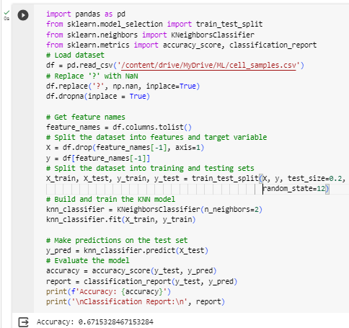

**Experiment-10**

**Objective :-** To Implement Random Forest in Python

**Dataset:-**  https://cf-courses-data.s3.us.cloud-object-storage.appdomain.cloud/IBMDeveloperSkillsNetwork-ML0101EN-SkillsNetwork/labs/Module%203/data/cell_samples.csv

**Implementation :-**

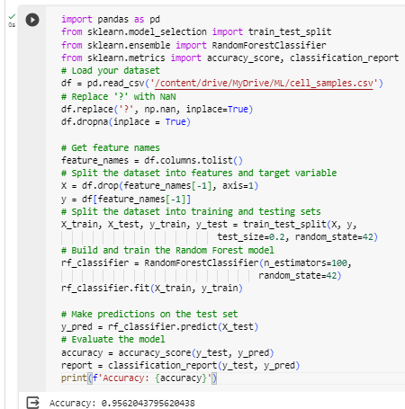

**Experiment-11**

**Objective :-** To Implement Naïve Bayes Classifier (NB) in Python

**Dataset:-**  https://cf-courses-data.s3.us.cloud-object-storage.appdomain.cloud/IBMDeveloperSkillsNetwork-ML0101EN-SkillsNetwork/labs/Module%203/data/cell_samples.csv

**Implementation :-**

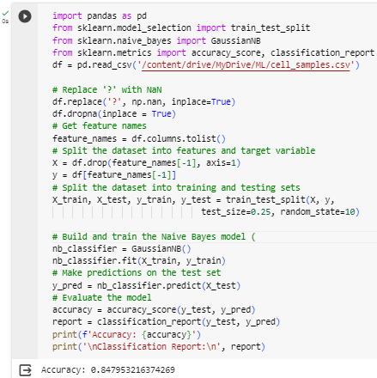

**Experiment-12**

**Objective :-** To Implement K-means Clustering in Python

**Dataset:-**  https://archive.ics.uci.edu/ml/machine-learning-databases/iris/iris.data

**Implementation :-**

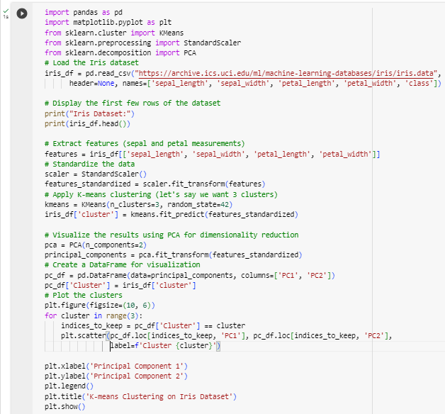

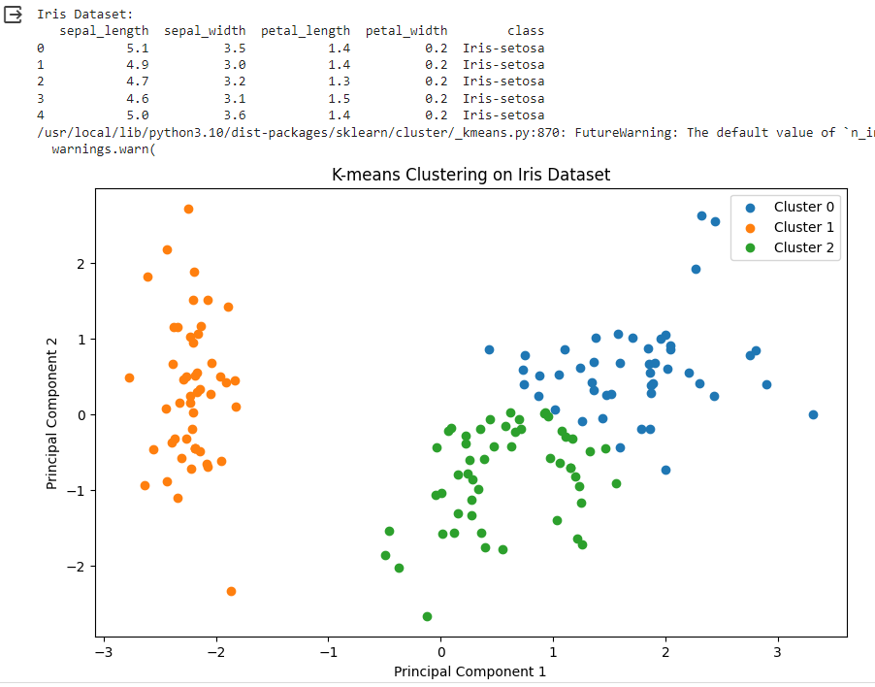

**Project**

**Objective :-** Classify the loan status using various classification algorithms and their comparison.

**Dataset:-**  <https://cf-courses-data.s3.us.cloud-object-storage.appdomain.cloud/IBMDeveloperSkillsNetwork-ML0101EN->SkillsNetwork/labs/FinalModule_Coursera/data/loan_train.csv

**Implementation :-**

